2.1

1. Free: where all the nodes are freely positioned

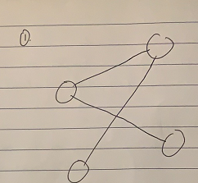

1. Styled: where all the nodes are positioned along helper structure in the background

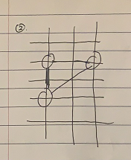

1. Fixed: where the positions of all nodes are fixed. (The background is a map of countries, and positions of circles means where the cities are)

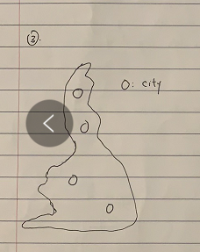

Force directed layout is a physical model where the edges are the springs, and vertices are the repulsive magnets. It is freely positioned. Nodes that have connections attract each other, and nodes that do not have connections repulse each other. However, force directed layouts requires very high amount of running time.

2.2

Box plots are used to represent statistical characteristics of a distribution. The vertical line defines the median, the box defines 50% of the data, and that the whiskers define depends on the plot design. For example, if could define all the data from the minimum to the maximum, of from Q1 to Q3. Only when we are trying to count, we should use bar charts, because in area that bar chart covers, there might not exist a single data point, so bar chart could not represent the exact statistical characteristics of a distribution. Dots that are not reached by the box or whiskeys are used to represent outliers.

2.3

All characteristics: the correct shapes of items, scale, area, angular

Pro of Mercator projection: the straight lines in the reality are not distorted on the map. Therefore, sailors will not be got lost when they are on the seas.

Cons of Mercator: the sizes of objects on the map are distorted, which do not reflect the actual size of objects.

2.4

Technique 1: use animation to encode time-dependent data

Technique 2: use stacked area chart to show composition that change over time

Technique 3: use multi-dimensional table, where the multiple slices of that cube represents the different points in the time that the data is measured

Technique 2 is preferred. Since animation and multi-dimensional table is interfering to people who see the visualization.